GRADE | SAMPLE PROBLEM/TASK | STANDARD
Work in vertical grade level teams and determine in which grade level you think the item would be used. Then find the specific standard that is congruent to each item. Did your initial prediction match? Where there any surprises? | 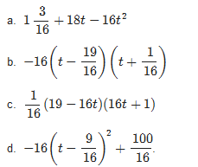  - The height (in feet) of a thrown horseshoe t seconds into flight can be described by the expression $1\frac{3}{16}+18t-16t^{2}$. The expressions (a)–(d) below are equivalent. Which is most useful for finding the maximum height of the horseshoe's path? Explain your reasoning. | A.SSE.1
 | - A fuel oil dealer buys 20,000 gallons of heating oil at $2.65 per gallon and another 14,000 gallons at $3.00 per gallon. (The oil is the same grade and quality, but the price varies due to the market.) He has a contract to sell up to 35,000 gallons of oil next month at $3.25 per gallon, but wants to use as much cash as possible immediately for future investments. To raise cash, he can sell some of his oil to another distributor, who will pay $2.75 per gallon now. How much investment money can the dealer raise now by selling oil and still be able to break even after selling the remainder next month? | N.Q.1
 | - Suppose a friend tells you she paid a total of $16,368 for a car, and you'd like to know the car's list price (the price before taxes) so that you can compare prices at various dealers. Find the list price of the car if your friend bought the car in:  - Arizona, where the sales tax is 6.6%.  - New York, where the sales tax is 8.25%.  - A state where the sales tax is r. | A.CED.1
 | - About how many cells are in the human body?  You can assume that a cell is a sphere with radius 10⁻³ cm and that the density of a cell is approximately the density of water which is 1g/cm³. | G.MG.2
 | 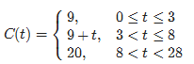  - In order to gain popularity among students, a new pizza place near school plans to oﬀer a special promotion. The cost of a large pizza (in dollars) at the pizza place as a function of time (measured in days since February 10th) may be described as  (Assume t only takes whole number values.)  - If you want to give their pizza a try, on what date(s) should you buy a large pizza in order to get the best price?  - How much will a large pizza cost on Feb. 18th?  - On what date, if any, will a large pizza cost 13 dollars?  - Write an expression that describes the sentence "The cost of a large pizza is at least A dollars B days into the promotion," using function notation and mathematical symbols only.  - Calculate C(9)−C(8) and interpret its meaning in the context of the problem.  - On average, the cost of a large pizza goes up about 85 cents per day during the ﬁrst two weeks of the promotion period. Which of the following equations best describes this statement?  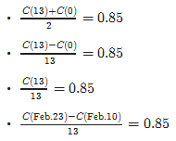 | F.IF.4
 | - From a class containing 12 girls and 10 boys, three students are to be selected to serve on a school advisory panel. Here are four different methods of making the selection.  I. Select the ﬁrst three names on the class roll.  II. Select the ﬁrst three students who volunteer.  III. Place the names of the 22 students in a hat, mix them thoroughly, and select three names from the mix.  IV. Select the ﬁrst three students who show up for class tomorrow.  Which is the best sampling method, among these four, if you want the school panel to represent a fair and representative view of the opinions of your class? Explain the weaknesses of the three you did not select as the best. | S.IC.1
 | - Which of the following could be modeled by y=2x+5? Answer YES or NO for each one.  - There are initially 5 rabbits on the farm. Each month thereafter the number of rabbits is 2 times the number in the month before. How many rabbits are there after x months?  - Joaquin earns $2.00 for each magazine sale. Each time he sells a magazine he also gets a five-dollar tip. How much money will he earn after selling x magazines?  - Sandy charges $2.00 an hour for babysitting. Parents are charged $5.00 if they arrive home later than scheduled. Assuming the parents arrived late, how much money does she earn for x hours?  - I have a sequence of integers. The first term of the sequence is 7 and the difference between any consecutive terms is always equal to 2.  - Sneak Preview is a members-only video rental store. There is a $2.00 initiation fee and a $5.00 per video rental fee. How much would John owe on his first visit if he becomes a member and rents x videos?  - Andy is saving money for a new CD player. He began saving with a $5.00 gift and will continue to save $2.00 each week. How much money will he have saved at the end of x weeks? | 8.F.1-3
 | - Today there is a 55% chance of rain, a 20% chance of lightning, and a 15% chance of lightning and rain together. Are the two events “rain today” and ”lightning today” independent events? Justify your answer.  - Now suppose that today there is a 60% chance of rain, a 15% chance of lightning, and a 20% chance of lightning if it’s raining. What is the chance of both rain and lightning today?  - Now suppose that today there is a 55% chance of rain, a 20% chance of lightning, and a 15% chance of lightning and rain. What is the chance that we will have rain or lightning today?  - Now suppose that today there is a 50% chance of rain, a 60% chance of rain or lightning, and a 15% chance of rain and lightning. What is the chance that we will have lightning today? | S.CP.2-5, 7
 | - Suppose A=(a₁, a₂) and B=(b₁, b₂) are two points in the plane, determined by constants a₁ ,a₂ , b₁, b₂. Suppose X=(x₁, x₂) is a third point, determined by the variables x₁ and x₂.  - Write an expression that gives the slope of line AX in terms of a₁, a₂, x₁, x₂. Write an expression that gives the slope of line BX in terms of b₁, b₂, x₁, x₂.  - Write a polynomial equation involving a₁ ,a₂ , b₁, b₂, x₁, x₂ that expresses that the lines AX and BX are perpendicular.  - What geometric figure is the solution set of the equation in b)? | G.GPE.1
 | - The diagram shows three glasses (not drawn to scale). The measurements are all in centimeters.  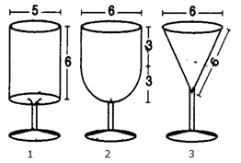  The bowl of glass 1 is cylindrical. The inside diameter is 5 cm and the inside height is 6 cm.  The bowl of glass 2 is composed of a hemisphere attached to cylinder. The inside diameter of both the hemisphere and the cylinder is 6 cm. The height of the cylinder is 3 cm. The bowl of glass 3 is an inverted cone. The inside diameter is 6 cm and the inside slant height is 6 cm.  - Find the vertical height of the bowl of glass 3.  - Calculate the volume of the bowl of each of these glasses.  - Glass 2 is filled with water and then half the water is poured out. Find the height of the water. | 8.G.7, 9
 | - Quincy is a tour guide at a museum of science and history. During a tour of the museum, he tells some visitors about a fossilized dinosaur bone that is on display in the museum. He says, “Twenty years ago, a group of paleontologists donated this dinosaur bone to our museum. At the time, they told us that they had estimated the age of the bone to be approximately 90 million years. So now, the bone is about 90 million and 20 years old.” Evaluate the validity of Quincy's statement. | N.Q.3
 | - The figure below shows the graphs of the exponential functions f(x)=c⋅3^{x} and g(x)=d⋅2^{x} , for some numbers c>0 and d>0 . They intersect at the point (p,q)  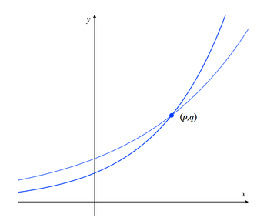  - Which is greater, c or d? Explain how you know.  - Imagine you place the tip of your pencil at (p,q) and trace the graph of g out to the point with x-coordinate p+2. Imagine I do the same on the graph of f. What will be the ratio of the y-coordinate of my ending point to the y-coordinate of yours? | F.LE.1
 | - Kimi and Jordan are each working during the summer to earn money in addition to their weekly allowance. Kimi earns $9 per hour at her job, and her allowance is $8 per week. Jordan earns $7.50 per hour, and his allowance is $16 per week.  - Jordan wonders who will have more income in a week if they both work the same number of hours. Kimi says, "It depends." Explain what she means.  - Is there a number of hours worked for which they will have the same income? If so, find that number of hours. If not, why not?  - What would happen to your answer to part (b) if Kimi were to get a raise in her hourly rate? Explain.  - What would happen to your answer to part (b) if Jordan were no longer to get an allowance? Explain. | F.BF.1
 | - A type of pasta is made of a blend of quinoa and corn. The pasta company is not disclosing the percentage of each ingredient in the blend but we know that the quinoa in the blend contains 16.2% protein, and the corn in the blend contains 3.5% protein. Overall, each 57 gram serving of pasta contains 4 grams of protein. How much quinoa and how much corn is in one serving of the pasta? | 8.EE.8c
 | 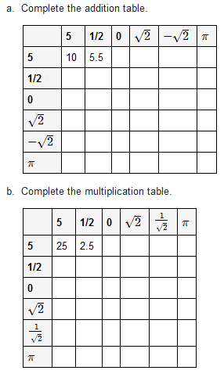  - Based on the above information, conjecture which of the statements is ALWAYS true, which is SOMETIMES true, and which is NEVER true?  - The sum of a rational number and a rational number is rational.  - The sum of a rational number and an irrational number is irrational.  - The sum of an irrational number and an irrational number is irrational.  - The product of a rational number and a rational number is rational.  - The product of a rational number and an irrational number is irrational.  - The product of an irrational number and an irrational number is irrational. | N.RN.3

