MDC and Baseline Data
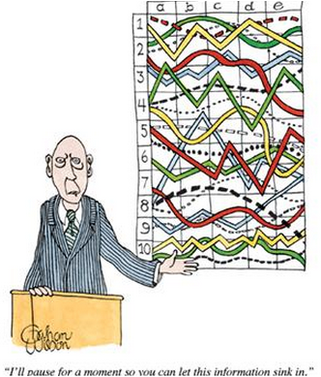
“I will pause for a moment to let the information sink in.”

“Hmmm… Let’s see…

Q: Where can we get baseline data? What are possible data sources?
- First -- The Context to establish needs
  - Demographics, Attitude and Aptitude
  - What assessments / tools can be used?
  - Where can we find them?
  - Can we create them?

- Match the need with the Enduring Skills / Understandings

- Consider “Proportional Reasoning” for a fictional 7th grade class.

- What are some sources of baseline data?
- Practice problem ( http://bit.ly/1mzsnmT )
  - What can this tell us?
  - Fill in chart

- Where can we find other potential data sources?
  - Let’s find some.

- Strengths and limitations of various sources of base line data
  - Next Step?

Examine the Enduring Understanding around Proportional Reasoning – 7th grade.

Lawn Mowing
What standards(s) does this activity address?
Enduring Understanding | Demonstrators | Related Standards | Sources of Evidence:  What is available or needs to be developed?
Students use the 8 Math Practices to develop understanding of proportional relationships.

(Understanding here is defined as students’ ability to access and perform the content through the 8 Practice Standards. See pg. 8 of standards document for further detail.)
 | Use understanding to solve single and multistep problems from the real world. | 7.RPA.1  7.PRA.2  7.EE  7.G.A.1
 | Use understanding to solve wide variety of percent problems. | 7.RPA.3  7.EE
 | Use understanding to solve problems about scale drawings. | 7.EE  7.G.A
 | Use understanding to graph proportional relationships, understand unit rate as an informal measure of slope. | 7.RP.A.2
 | Use understanding to distinguish proportional relationships from others. | 7.RP.A.2
 | This is critical in students’ journey to understand equations and use them to describe numbers and analyze relationships and to understand transformations and use them to describe and analyze relationships between and within figures in the Euclidean and Coordinate planes.

Sources of baseline data
- Shell Center task and tests (Search by Standards)
  - http://map.mathshell.org/materials/index.php

- Illustrative Math
  - https://www.illustrativemathematics.org/illustrations/1550

- Formative Assessment lessons (Shell Center Lessons Grade 7) -- When can this be used?
  - http://map.mathshell.org/materials/lessons.php

- Inside Math (Common Core Standards Math Content Standards)
  - http://www.insidemathematics.org/index.php/7th-grade
More on Enduring Understandings in Math

Link(s) to Common Core Tools site that helps with seeing the progression and connection between the standards. Specifically the introduction on pages 1 – 8 and the overviews. Examples of the overviews are found on pages 27, 33, 39, 46 and 52.
http://commoncoretools.me/wp-content/uploads/2011/02/ccssi_math_standards_hyperlinked_1-0.pdf

(Shortened URL for the same site.) http://bit.ly/1jIdef6

Here’s another resource:
http://matheducation-thenextfiveyears.wikispaces.com/Common+Core+Standards#progressiondocs
It does a good job at looking at the progressions from grade to grade…

This image from the pages above also helps:
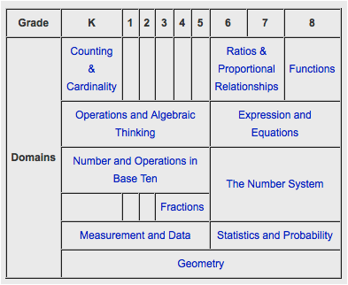

The shifts are important as well…
The following are the key shifts called for by the Common Core:
( From: http://www.corestandards.org/other-resources/key-shifts-in-mathematics/ )
- Greater focus on fewer topics The Common Core calls for greater focus in mathematics. Rather than racing to cover many topics in a mile-wide, inch-deep curriculum, the standards ask math teachers to significantly narrow and deepen the way time and energy are spent in the classroom. This means focusing deeply on the major work of each grade as follows:
  - In grades K–2: Concepts, skills, and problem solving related to addition and subtraction
  - In grades 3–5: Concepts, skills, and problem solving related to multiplication and division of whole numbers and fractions
  - In grade 6: Ratios and proportional relationships, and early algebraic expressions and equations
  - In grade 7: Ratios and proportional relationships, and arithmetic of rational numbers
  - In grade 8: Linear algebra and linear functions
This focus will help students gain strong foundations, including a solid understanding of concepts, a high degree of procedural skill and fluency, and the ability to apply the math they know to solve problems inside and outside the classroom.
- Coherence: Linking topics and thinking across grades Mathematics is not a list of disconnected topics, tricks, or mnemonics; it is a coherent body of knowledge made up of interconnected concepts. Therefore, the standards are designed around coherent progressions from grade to grade. Learning is carefully connected across grades so that students can build new understanding onto foundations built in previous years. For example, in 4th grade, students must “apply and extend previous understandings of multiplication to multiply a fraction by a whole number” (Standard 4.NF.4). This extends to 5th grade, when students are expected to build on that skill to “apply and extend previous understandings of multiplication to multiply a fraction or whole number by a fraction” (Standard 5.NF.4). Each standard is not a new event, but an extension of previous learning.
Coherence is also built into the standards in how they reinforce a major topic in a grade by utilizing supporting, complementary topics. For example, instead of presenting the topic of data displays as an end in itself, the topic is used to support grade-level word problems in which students apply mathematical skills to solve problems.
- Rigor: Pursue conceptual understanding, procedural skills and fluency, and application with equal intensity Rigor refers to deep, authentic command of mathematical concepts, not making math harder or introducing topics at earlier grades. To help students meet the standards, educators will need to pursue, with equal intensity, three aspects of rigor in the major work of each grade: conceptual understanding, procedural skills and fluency, and application.
Conceptual understanding: The standards call for conceptual understanding of key concepts, such as place value and ratios. Students must be able to access concepts from a number of perspectives in order to see math as more than a set of mnemonics or discrete procedures.
Procedural skills and fluency: The standards call for speed and accuracy in calculation. Students must practice core functions, such as single-digit multiplication, in order to have access to more complex concepts and procedures. Fluency must be addressed in the classroom or through supporting materials, as some students might require more practice than others.
Application: The standards call for students to use math in situations that require mathematical knowledge. Correctly applying mathematical knowledge depends on students having a solid conceptual understanding and procedural fluency.

