

Geometry

Partitioning the Whole into Equal Shares

Grade 2

Formative Assessment Lesson

Problem Solving Formative Assessment Lesson

Designed and revised by the Kentucky Department of Education

Field-tested by Kentucky Mathematics Leadership Network Teachers

Rights and Usage Agreement: <https://creativecommons.org/licenses/by/4.0/>

If you encounter errors or other issues with this file, please contact the KDE math team at:

kdemath@education.ky.g)

|  |
| --- |
| **Partitioning the Whole Into Equal Shares Grade 2** |

This Formative Assessment Lesson is designed to be part of an instructional unit. This task should be implemented approximately two-thirds of the way through the instructional unit. The results of this task should be used to inform the instruction that will take place for the remainder of your unit.

**Mathematical goals**

This lesson is intended to help you assess how well students are able to:

* Recognize equal shares of a rectangular figure with partitioned rows and columns of same-size rectangles
* Partition circles, rectangles, and other polygons into two, three, or four equal shares describing the whole as halves, thirds, or fourths
* Recognize equal shares of the whole do not have to be the same shape.

**Kentucky Academic Standards:**

**This lesson involves *mathematical content* in the standards within the grade, with emphasis on:**

**Second grade-Geometry**

**Reason with shapes and their attributes.**

**[2.G.A.1](http://www.corestandards.org/Math/Content/2/G/A/1/)**  
Recognize and draw shapes having specified attributes, such as a given number of angles or a given number of equal faces.1 Identify triangles, quadrilaterals, pentagons, hexagons, and cubes.

**[2.G.A.2](http://www.corestandards.org/Math/Content/2/G/A/2/)**  
Partition a rectangle into rows and columns of same-size squares and count to find the total number of them.

**[2.G.A.3](http://www.corestandards.org/Math/Content/2/G/A/3/)**  
Partition circles and rectangles into two, three, or four equal shares, describe the shares using the words halves, thirds, half of, a third of, etc., and describe the whole as two halves, three thirds, four fourths. Recognize that equal shares of identical wholes need not have the same shape.

**This lesson involves a range of *Standards for Mathematical Practice,* with emphasis on:**

**MP-2. Reason abstractly and quantitatively**

**MP-3. Construct viable arguments and critique the reasoning of others**

**MP-4. Model with math**

**MP-6. Be precise**

**Introduction**

This lesson is structured in the following way:

* Before the lesson, students work individually on the task *Partitioning the Whole Into Equal Shares* *Pre Lesson Assessment*. The task is designed to reveal their current understandings and difficulties. You then review/analyze their responses and create questions for students to consider/answer in order to improve their solutions.
* After a whole class introduction, students work collaboratively on a card sorting activity.
* Students work with a partner or in small groups on collaborative discussion tasks. Throughout their work, students justify and explain their decisions to their peers.
* Toward the end of the lesson there is a whole class discussion.
* Students return to their original assessment tasks or a similar task and try to improve their own responses.

**Materials required**

Each individual student will need:

* The *Partitioning the Whole into Equal Shares Pre-Lesson Assessment* for each student. (Also may be used as post-assessment.)

Each small group of students will need the following resources:

* One legal sized paper for each pair of students for sorting cards
* Post-its
* **Card Set A** of 2-D Shapes and **Card Set B** of Rectangles partitioned into equal squares

**Time needed**

Approximately 30 minutes before the lesson for the individual assessment task, one 60 minute lesson, and 30 minutes for a follow-up lesson for students to revisit individual assessment task will be needed. Timings given are approximated. All students need not complete all sets of cards activities. Exact timings will depend on the needs of the class.

**Before the Lesson**

**Assessment task: (Partitioning the Whole into Equal Shares)**

Have students do this task individually in class a day or more before the formative assessment lesson. This will give you an opportunity to assess the work, and to find out the kinds of difficulties students have with it. You will be able to target your help more effectively in the follow-up lesson. Depending on your class you can have them do it all at once or in small groups (they should still work individually.)

**Framing the pre-assessment: (10-15 minutes)**

Give each student a copy of the assessment task (Partitioning the Whole into Equal Shares)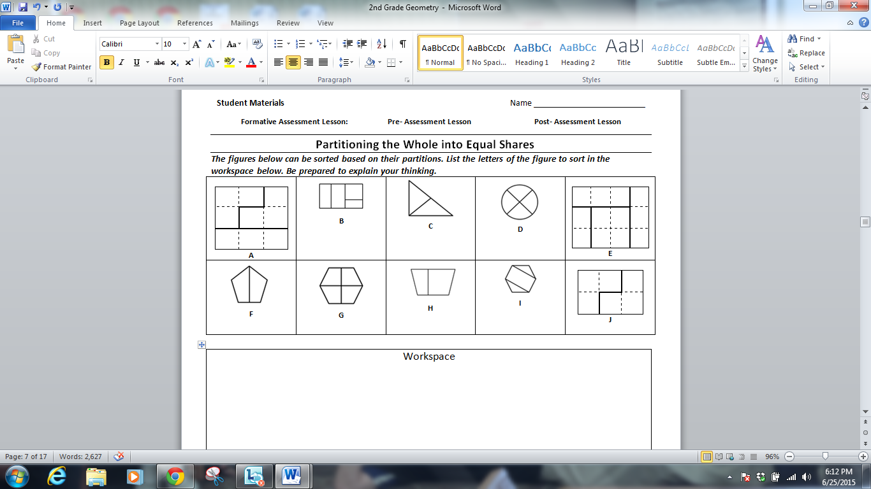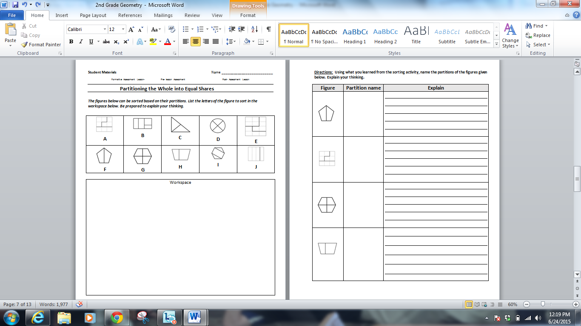

*“Today we are going to work on a task for naming the equal shares for which wholes have been partitioned. This task is to help me see ways that I can help you if you are having any problems with naming and explaining your reasoning for naming those shares of the whole. Our goal today is not to sort the shape by its name. (ie. hexagon, trapezoid, etc.) If you are not sure about all of your answers, it is okay. We are going to do an activity that will help you improve. You will* *sort the figures based on their partitions. List the letters of the figure as you sort them in the workspace below. Be prepared to explain your thinking.”*

It is important that the students are allowed to answer the questions without your assistance, as far as possible. If students struggle to get started ask questions that help them understand what they are being asked to do, but do not do the problem for them. See the *Common Issues* table.

Students should not worry too much if they do not understand or cannot do everything, because in the next lesson they will engage in a similar task, which should help them. Explain to students that by the end of the next lesson, they should expect to answer questions such as the ones below confidently.

**Assessing students’ responses**

Collect students’ responses to the task. Make notes about what their work reveals about their current levels of understanding and their different problem solving approaches. Partner/group students with others who displayed similar errors/misconceptions on the pre-assessment task.

We suggest that you do not score student’s work. The research shows that this will be counterproductive, as it will encourage students to compare their scores, and will distract their attention from what they can do to improve their mathematics.

Instead, help students to make further progress by summarizing their difficulties as a series of questions. Some questions in the *Common Issues* table may serve as examples. These questions have been drawn from commonly identified student misconceptions.

We recommend you either:

* write one or two questions on each student’s work, or
* give each student a printed version of your list of questions and highlight the questions for each individual student or
* display a small list of questions on the board that will be of help to the majority of students

Below is a list of common issues and questions/prompts that may be written on individual tasks, on the board or asked during the collaborative activity to help students clarify and extend their thinking

|  |  |
| --- | --- |
| **Common Issues:** | **Suggested questions and prompts:** |
| **Students have a difficult time getting started.** | * What are the directions? Read them again please. * What do you think you might try first? |
| **Students identify half as two parts as opposed to two equal parts, thirds as three parts as opposed to three equal parts, fourth as four parts as opposed to four equal parts.** | * How many parts have you counted within the whole? * What is special about these parts? * If the whole figure were a cookie or pizza, how would each person get a fair share? |
| **Students may name the partition two’s, three’s, four’s as opposed to the correct terminology of halves, thirds, and fourths.** | * If the parts you are counting make up one whole figure, what might be the correct name for those equal partitions? |
| **Students think equal parts must be the same size and same shape when rectangles have been partitioned into equal shares.** | * If the squares in this rectangle figure are all the same size and there is the same amount of squares in each divided part, how might you prove the parts are equal? |
| **Students find the task/lesson too easy.** | * *What shapes might you draw on the grid paper to challenge a friend?* * *Can you partition shapes into sixths and eighths?* |
|  |  |
|  |  |

**Suggested lesson outline**

**Whole Class Introduction (15 minutes)**

*Today we are going to do some more work on partitioning figures and equal shares. Let’s play a game, I’m going to show you a figure and I want you decide which side of the t-chart the figure belongs* ***Fair Share*** *or* ***Not Fair Share****.**Think about the strategies we have used for partitioning rectangles and circles to justify to your shoulder partner which side of the t-chart you think the figure I show belongs.*

Teachers may use cards from any of the card sorts A and B to use in this whole class introduction activity or you could make up your own cards. This activity will help students have a preview of what they are to do in the collaborative activity especially working with the mathematical discourse of where the figure belongs and why.

**Collaborative Activity: (20-30 minutes)**

Strategically group students based on pre-assessment data into groups of two or three students. With larger groups, some students may not fully engage in the task. Group each student with others who displayed similar errors/misconceptions on the pre-assessment task.

Explain to students how they are to work collaboratively:

*“You are now going to work together. You and your partner will get a bag of cards labeled CARD SET A. Sort these figures by your choice. It is an open sort. (MP-3) As you place the cards in a group, explain your thinking clearly to your partner. If your partner disagrees with your placement then challenge him or her to explain why. It is important that you both understand why each card is placed where it is.*

*There is a lot of work to do today and you may not all finish. The important thing is to learn something new, so take your time.* “

Give each group 10-15 minutes for Card Set A. Teacher monitors and professionally notices for a group to sort based on partitions (MP-2). Ask students, “Why did you sort them this way?” and “What could you name these categories/groups?” Encourage students to use given post it notes and based on discussions to name the categories. After several groups have named their categories have them share their thinking. Although, if this does not happen, intentionally use the document camera and make a beginning sort by halves, thirds, or fourths with only a couple of figures in each category. Prompt students, “Do you think you could continue the sort based on this one so far?”

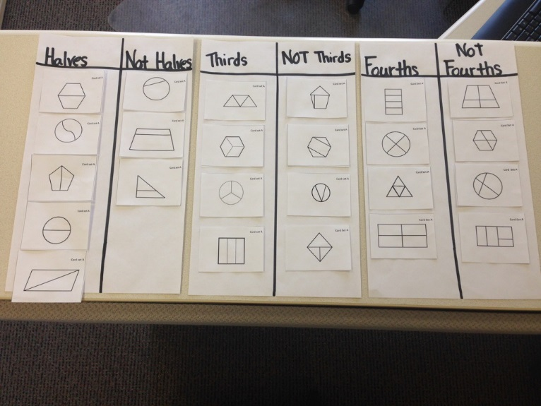

**Card Set A**

*Now you are going to get a new bag of figures called* ***Card Set B****. Using post it notes from Card Sort A as the category headers, what categories might you place each figure? As you place the cards in a group, explain your thinking clearly to your partner. (MP-3) If your partner disagrees with your placement then challenge him or her to explain why. It is important that you both understand why each card is placed where it is.*

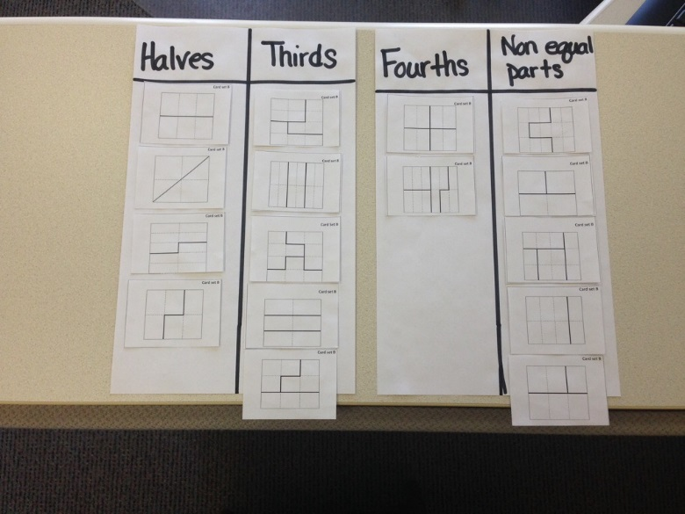

**Card Set B**

The purpose of this structured work is to encourage students to engage with each other’s explanations and take responsibility for each other’s understanding.

**Make a note of student approaches to the task**

Your tasks during the small group work are to listen and watch students work - make notes of student approaches to the task, and to support student problem solving. As you monitor the work, listen to the discussion and ask questions to help students understand concepts and clarify misconceptions.

You can then use this information to focus a whole-class discussion towards the end of the lesson. In particular, notice any common mistakes. For example, what new discoveries did you make during the sort of Card Set A? How did Card Set A help you when sorting Card Set B?

**Support student problem solving**

Try not to make suggestions that move students toward a particular approach to the task. Instead, ask questions to help students clarify their thinking. Encourage students to use each other as a resource for learning. Encourage students to explain their reasoning carefully.

If one student has placed a particular card on the chart, challenge their partner to provide an explanation.

If you find students have difficulty articulating their decisions, then you may want to use the questions from the *Common Issues* table to support your questioning.

If the whole class is struggling on the same issue, then you may want to write a couple of questions on the board and engineer a quick whole class discussion.

The rest of this part of the template should be directions related to this particular task.

**Taking two class periods to complete all activities**

If you have to divide the lesson into two class periods, you may want to have a way for students to save the work they have done with the place card sets. You may have each group tape the cards down with on their place cards. You may choose to have them do this even if you are not dividing up the class period just to use as a visual during the class discussion.

**Sharing Work (10 – 20 minutes)**

As students complete each sort, take a gallery walk and allow groups to compare their sorts to other groups. Students are permitted to ask questions and make changes to their original work.

**Extension activities-Card Set C** (polygon outlines) **& Card Set D** (Rectangles partitioned by same sized rectangles)can be used to challenge students to partition given figures, especially for students who mastered the goal in the pre-assessment. (MP-2, MP-6)) These answer keys are only a possible solution there are more.

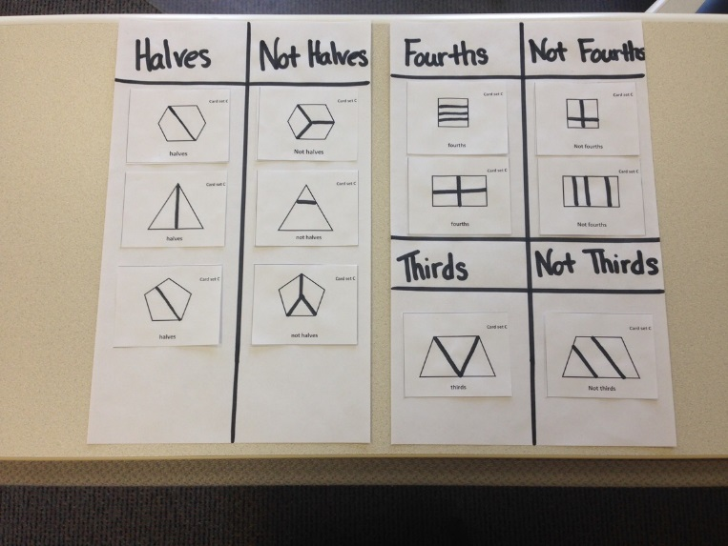 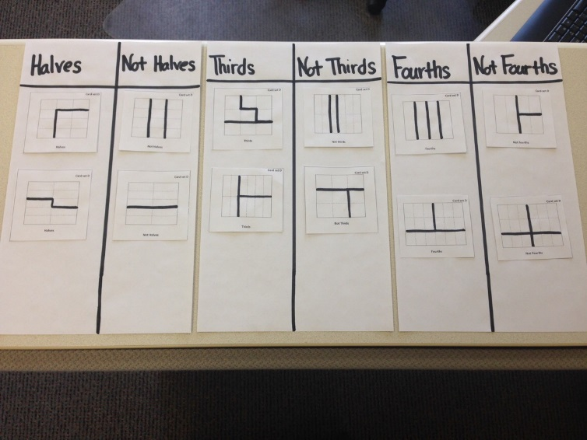

**Card Set C Card Set D**

**Whole-class discussion (10 minutes)**

Conclude the lesson by discussing and generalizing what has been learned. The generalization involves first extending what has been learned to new examples, and then examining some of the conclusions students came up with. Allow groups to bring up some of their work samples and share their thinking. The purpose of this discussion is to explore the processes involved in a range of different approaches. The aim is to get students to understand and share their reasoning, not just checking that everyone found the correct matches.

Ask students:

*Why did you decide to place that card there?*

*What clues did you use to help you in your decision?*

*Is there another card that could go there?*

You may also want to go back and refer to the t-chart of Fair Shares or Not Fair Shares and look to see if cards need to be moved and why?

**Improving individual solutions to the assessment task (10 minutes)**

Give the students a new copy of the original task,

*Think about what you have learned during this lesson. Using what you have learned try to improve your work.*

To focus your students, refer to the common issues chart. Use the questions which reflect the greatest need(s) of your students. This lesson format was designed from the Classroom Challenge Lessons intended for students in grades 6 through 12 from the [Math Assessment Project](http://map.mathshell.org/materials/lessons.php?taskid=488&subpage=problem).

**Student Materials** Name _________________________

**Formative Assessment Lesson: Pre- Assessment Lesson Post- Assessment Lesson**

**Partitioning the Whole into Equal Shares**

***The figures below can be sorted based on their partitions. List the letters of the figure to sort in the workspace below. Be prepared to explain your thinking.***

|  |  |  |  |  |  |  |  |  |  |  |  |  |  |  |  |  |  |  |  |  |  |  |  |  |  |
| --- | --- | --- | --- | --- | --- | --- | --- | --- | --- | --- | --- | --- | --- | --- | --- | --- | --- | --- | --- | --- | --- | --- | --- | --- | --- |
| |  |  |  | | --- | --- | --- | |  |  |  | |  |  |  | |  |  |  |   **A** | **B** | **C** | **D** | |  |  |  |  | | --- | --- | --- | --- | |  |  |  |  | |  |  |  |  | |  |  |  |  |   **E** |
| **F** | **G** | **H** | **I** | |  |  |  | | --- | --- | --- | |  |  |  | |  |  |  |   **J** |

|  |
| --- |
| Workspace |

**Directions: Using what you learned from the sorting activity, name the partitions of the figures given below. Explain your thinking.**

|  |  |  |
| --- | --- | --- |
| **Figure** | **Partition name** | **Explain** |
|  |  |  |
| |  |  |  | | --- | --- | --- | |  |  |  | |  |  |  | |  |  |  | |  |  |
|  |  |  |
|  |  |  |

|  |  |
| --- | --- |
| **Card set A** | **Card set A** |
| **Card set A** | **Card set A** |
| **Card set A** | **Card set A** |
| **Card set A** | **Card set A** |

|  |  |
| --- | --- |
| **Card set A** | **Card set A**  **[http://exchangedownloads.smarttech.com/public/content/67/67896625-345f-4346-85b7-a38548164e4f/previews/medium/0001.png](http://www.google.com/url?sa=i&rct=j&q=&esrc=s&frm=1&source=images&cd=&cad=rja&uact=8&ved=0CAcQjRw&url=http://exchange.smarttech.com/details?id%3D67896625-345f-4346-85b7-a38548164e4f&ei=uLyJVfnkINieyASV9KSABg&bvm=bv.96339352,d.cGU&psig=AFQjCNE-xUPiuKhPmbtJi6tebAp_fzsVbg&ust=1435176488265165)** |
| **Card set A** | **Card set A**  **[http://www.diagrami.com/diagrams/polyhedrons/b3step1.gif](http://www.google.com/url?sa=i&rct=j&q=&esrc=s&frm=1&source=images&cd=&cad=rja&uact=8&ved=0CAcQjRw&url=http://www.diagrami.com/diagrams.php?shape%3Dpolyhedrons2&ei=Yb2JVdSVAYT4yQTRwoOoBQ&bvm=bv.96339352,d.cGU&psig=AFQjCNF7w08KNtNFVZd9_GLEw5WEdxYAmQ&ust=1435176632332784)** |
| **Card set A** | **Card set A** |
| **Card set A** | **Card Set A** |

|  |  |
| --- | --- |
| **Card Set A** | **Card Set A** |
| **Card Set A** | **Card Set A** |
| **Card Set A** | **Card Set A** |
| **Card Set A** | **Card Set A** |

|  |  |  |  |  |  |  |  |  |  |  |  |  |  |  |  |
| --- | --- | --- | --- | --- | --- | --- | --- | --- | --- | --- | --- | --- | --- | --- | --- |
| **Card set B**   |  |  |  | | --- | --- | --- | |  |  |  | |  |  |  | | **Card set B**   |  |  |  |  | | --- | --- | --- | --- | |  |  |  |  | |  |  |  |  | |
| **Card set B**   |  |  |  | | --- | --- | --- | |  |  |  | |  |  |  | | **Card set B**   |  |  | | --- | --- | |  |  | |  |  | |
| **Card set B**   |  |  |  | | --- | --- | --- | |  |  |  | |  |  |  | | **Card set B**   |  |  |  | | --- | --- | --- | |  |  |  | |  |  |  | |  |  |  | |
| **Card set B**   |  |  | | --- | --- | |  |  | |  |  | |  |  | |  |  | |  |  | | **Card set B**   |  |  |  |  |  | | --- | --- | --- | --- | --- | |  |  |  |  |  | |  |  |  |  |  | |  |  |  |  |  | |

|  |  |  |  |  |  |  |  |  |  |  |  |
| --- | --- | --- | --- | --- | --- | --- | --- | --- | --- | --- | --- |
| **Card set B**   |  |  | | --- | --- | |  |  | |  |  | |  |  | | **Card set B**   |  |  | | --- | --- | |  |  | |  |  | |
| **Card set B**   |  |  |  |  |  |  | | --- | --- | --- | --- | --- | --- | |  |  |  |  |  |  | |  |  |  |  |  |  | | **Card set B**   |  |  |  |  |  |  | | --- | --- | --- | --- | --- | --- | |  |  |  |  |  |  | |  |  |  |  |  |  | |
| **Card set B**   |  |  |  |  | | --- | --- | --- | --- | |  |  |  |  | |  |  |  |  | | **Card set B**   |  |  |  | | --- | --- | --- | |  |  |  | |  |  |  | |  |  |  | |  |  |  | |
| **Card set B**   |  |  |  |  | | --- | --- | --- | --- | |  |  |  |  | |  |  |  |  | |  |  |  |  | | **Card Set B**   |  |  |  | | --- | --- | --- | |  |  |  | |  |  |  | |  |  |  | |  |  |  | |

|  |  |
| --- | --- |
| **Card set C**  **halves** | **Card set C**    **not halves** |
| **Card set C**  **thirds** | **Card set C**  **fourths** |
| **Card set C**  **halves** | **Card set C**  **fourths** |

|  |  |
| --- | --- |
| **Card set C**  **halves** | **Card set C**    **not halves** |
| **Card set C**  **Not thirds** | **Card set C**  **Not fourths** |
| **Card set C**  **Not halves** | **Card set C**  **Not fourths** |

|  |  |  |  |  |  |  |  |  |  |  |  |  |  |  |  |  |  |  |  |
| --- | --- | --- | --- | --- | --- | --- | --- | --- | --- | --- | --- | --- | --- | --- | --- | --- | --- | --- | --- |
| **Card set D**   |  |  |  | | --- | --- | --- | |  |  |  | |  |  |  | |  |  |  |   **Thirds** | **Card set D**   |  |  |  | | --- | --- | --- | |  |  |  | |  |  |  | |  |  |  |   **Not Thirds** |
| **Card set D**   |  |  | | --- | --- | |  |  | |  |  | |  |  | |  |  | |  |  |   **Halves** | **Card set D**   |  |  | | --- | --- | |  |  | |  |  | |  |  | |  |  | |  |  |   **Not Halves** |
| **Card set D**   |  |  |  |  |  |  | | --- | --- | --- | --- | --- | --- | |  |  |  |  |  |  | |  |  |  |  |  |  | |  |  |  |  |  |  |   **Fourths** | **Card set D**   |  |  |  |  |  |  | | --- | --- | --- | --- | --- | --- | |  |  |  |  |  |  | |  |  |  |  |  |  | |  |  |  |  |  |  |   **Not Fourths** |

|  |  |  |  |  |  |  |  |  |  |  |  |  |  |  |  |  |  |  |  |  |  |  |  |  |  |
| --- | --- | --- | --- | --- | --- | --- | --- | --- | --- | --- | --- | --- | --- | --- | --- | --- | --- | --- | --- | --- | --- | --- | --- | --- | --- |
| **Card set D**   |  |  |  | | --- | --- | --- | |  |  |  | |  |  |  | |  |  |  | |  |  |  |   **Halves** | **Card set D**   |  |  |  | | --- | --- | --- | |  |  |  | |  |  |  | |  |  |  | |  |  |  |   **Not Halves** |
| **Card set D**   |  |  |  |  |  |  | | --- | --- | --- | --- | --- | --- | |  |  |  |  |  |  | |  |  |  |  |  |  |   **Thirds** | **Card set D**   |  |  |  |  |  |  | | --- | --- | --- | --- | --- | --- | |  |  |  |  |  |  | |  |  |  |  |  |  |   **Not thirds** |
| **Card set D**   |  |  |  |  | | --- | --- | --- | --- | |  |  |  |  | |  |  |  |  |   **fourths** | **Card set D**   |  |  |  |  | | --- | --- | --- | --- | |  |  |  |  | |  |  |  |  |   **Not fourths** |