Student Work Cover Sheet
(Please complete in pen.)

Formative Assessment Lesson and Number:
Pre- or Post -Lesson Assessment (circle one)
Date:
State:
District:
School:
Teacher:
Teacher e-mail:
Grade:
Class (e.g., Alg 1, Geom.):
Notes on Class (i.e., accelerated, integrated, collaborative, special needs, etc.):

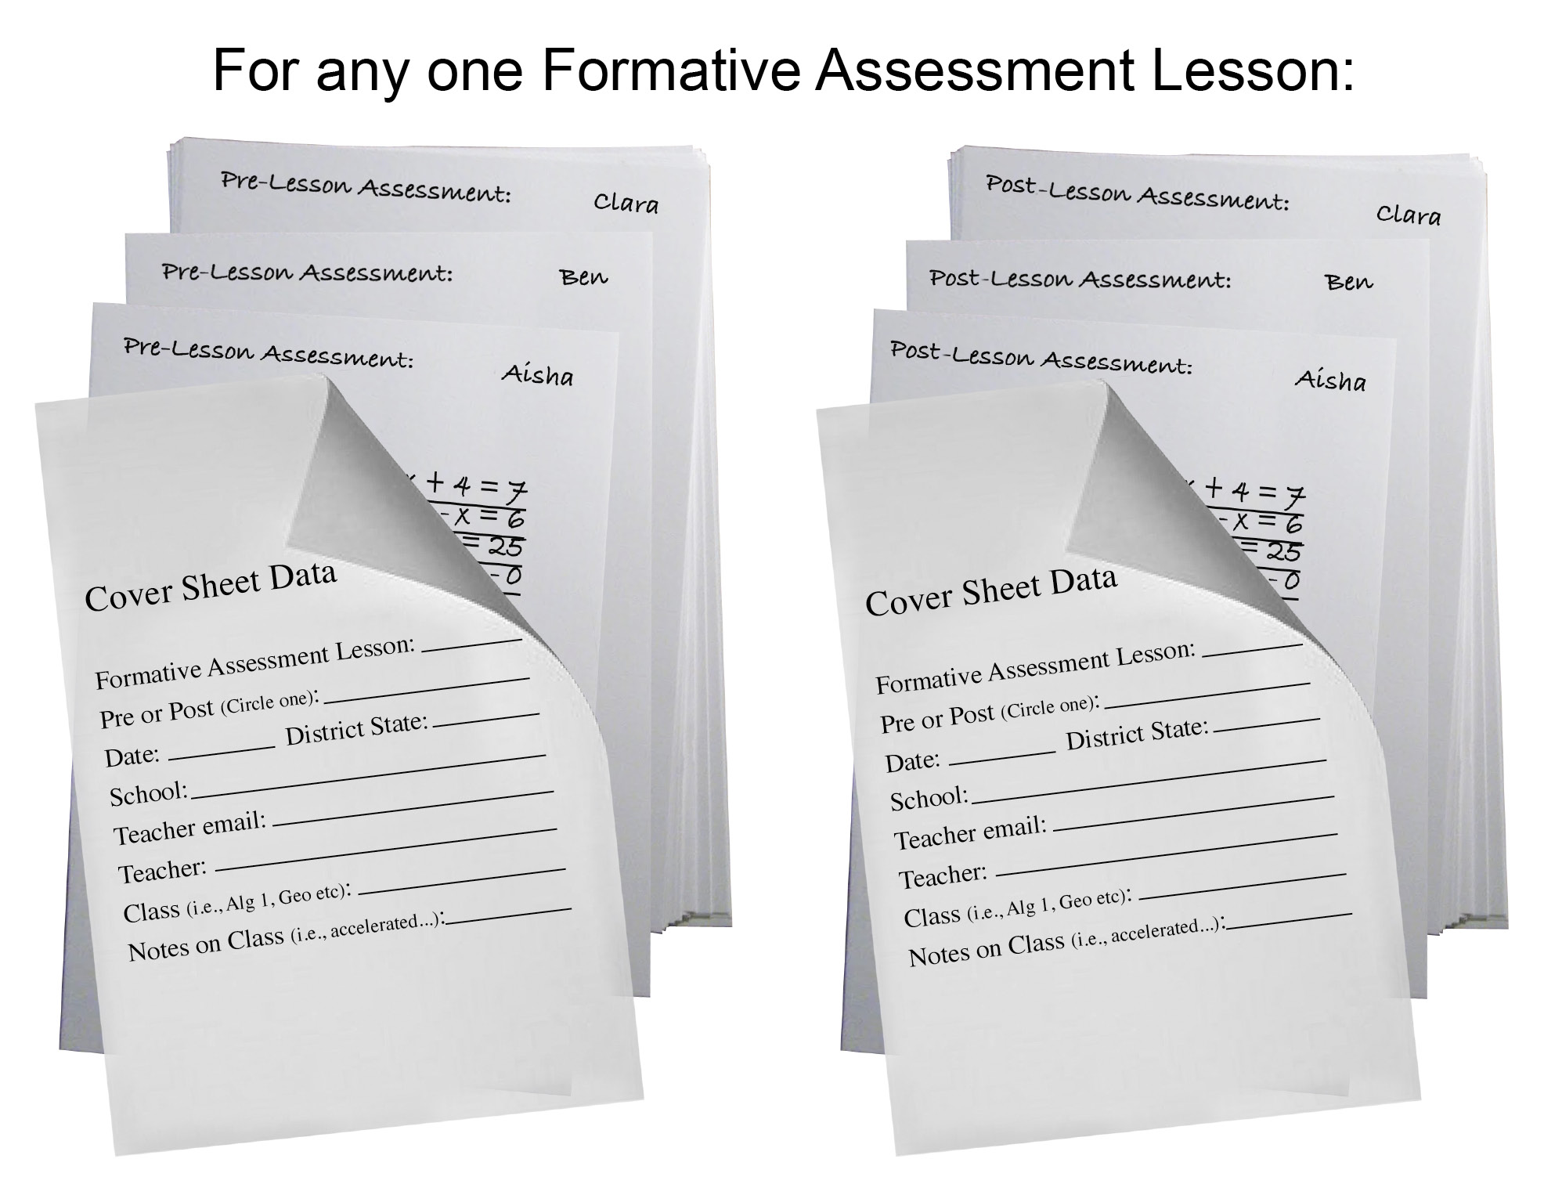

Notes for Compiling Student Work
Your students’ work is very important to us, and we need your help in managing its collection.
Since you will be sorting both the Pre- and Post-Lesson Assessments into the same student order for analysis, it would help us enormously if you could send them to us in that same sorted order (see illustration).
Once the two stacks for a particular class are assembled, please pass them along to your School Teacher-Leader.
Since this student work will be digitized, please copy the Pre- and Post-Lesson Assessments on white paper and have the students use pen or dark pencil to improve readability.
We ask you to complete two copies of this cover sheet for each class; please place one on top of the stack of Pre-Lesson Assessments, and the other on top of the stack of Post-Lesson Assessments.
The student work will be used to create workshop sample sets for The Bill & Melinda Gates Foundation’s MDC Website and become part of the College Ready Tools. It will also contribute to the digitization of the Formative Assessment Lessons by the FACT Project.
Thank you so much!

